**Capstone Project (ICLEAF)**

**Candidate Name:** Roma Mittal

**Amazon Id:** rommitta@amazon.com

**Project GitHub repository link:** <https://github.com/Roma-Mittal/Project-Roma>

***Task 1 (Library management System)***

* Creation of tables and Insertion of sample data

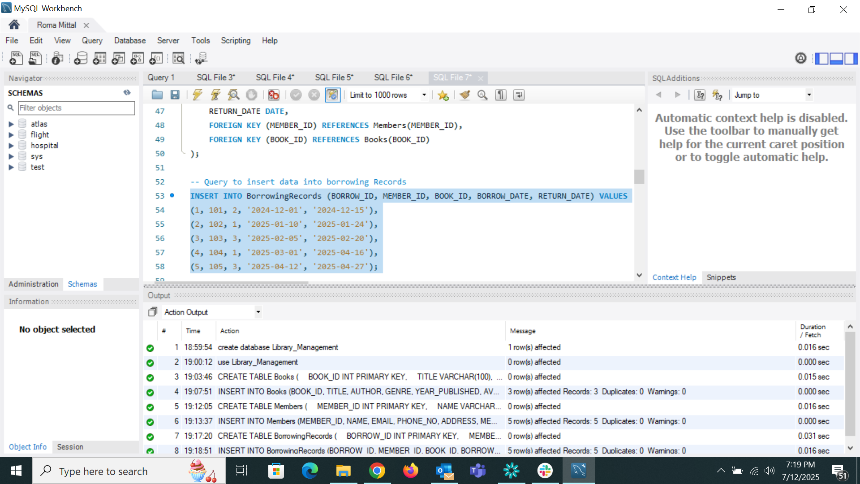

* Retrieve a list of books currently borrowed by a specific member

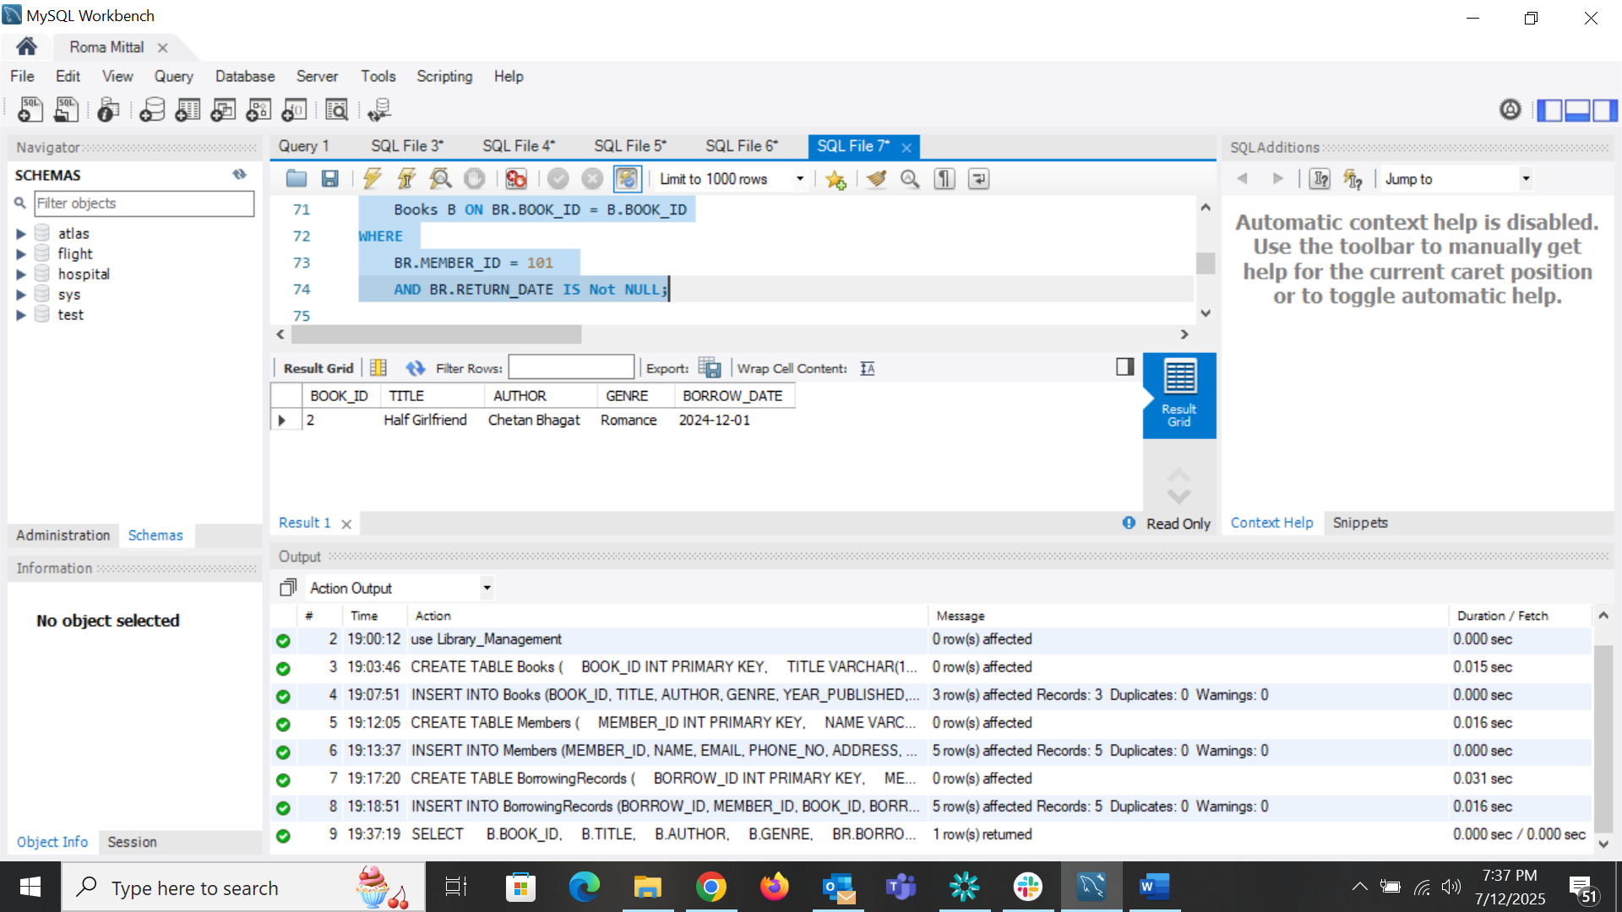

* Find members who have overdue books (borrowed more than 30 days ago, not returned). My sample data do not have any unreturned value

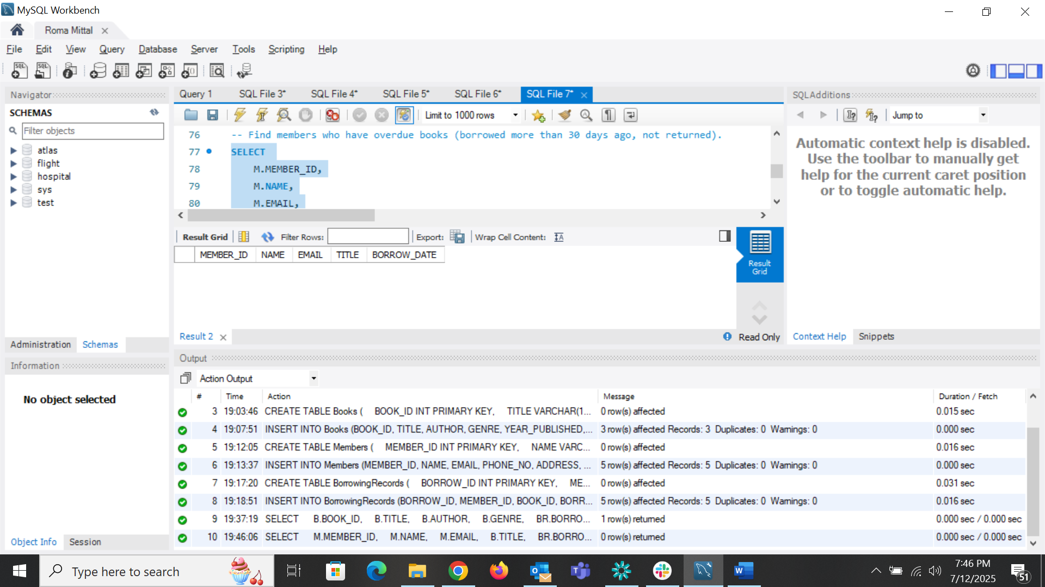

* Retrieve books by genre along with the count of available copies.

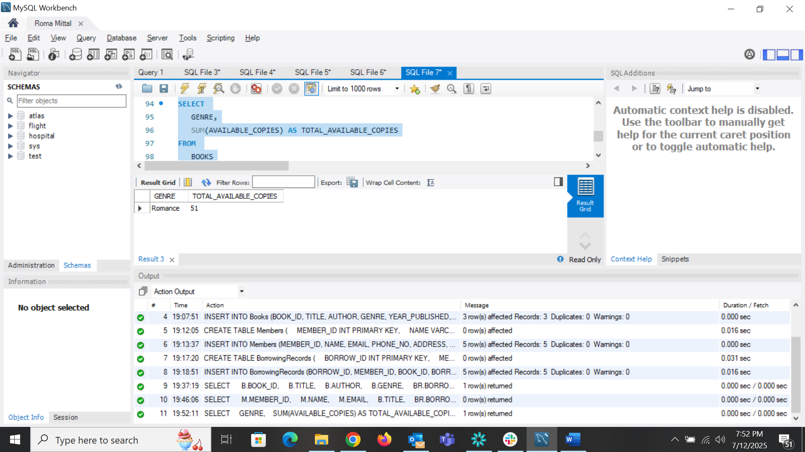

* Find the most borrowed book(s) overall.

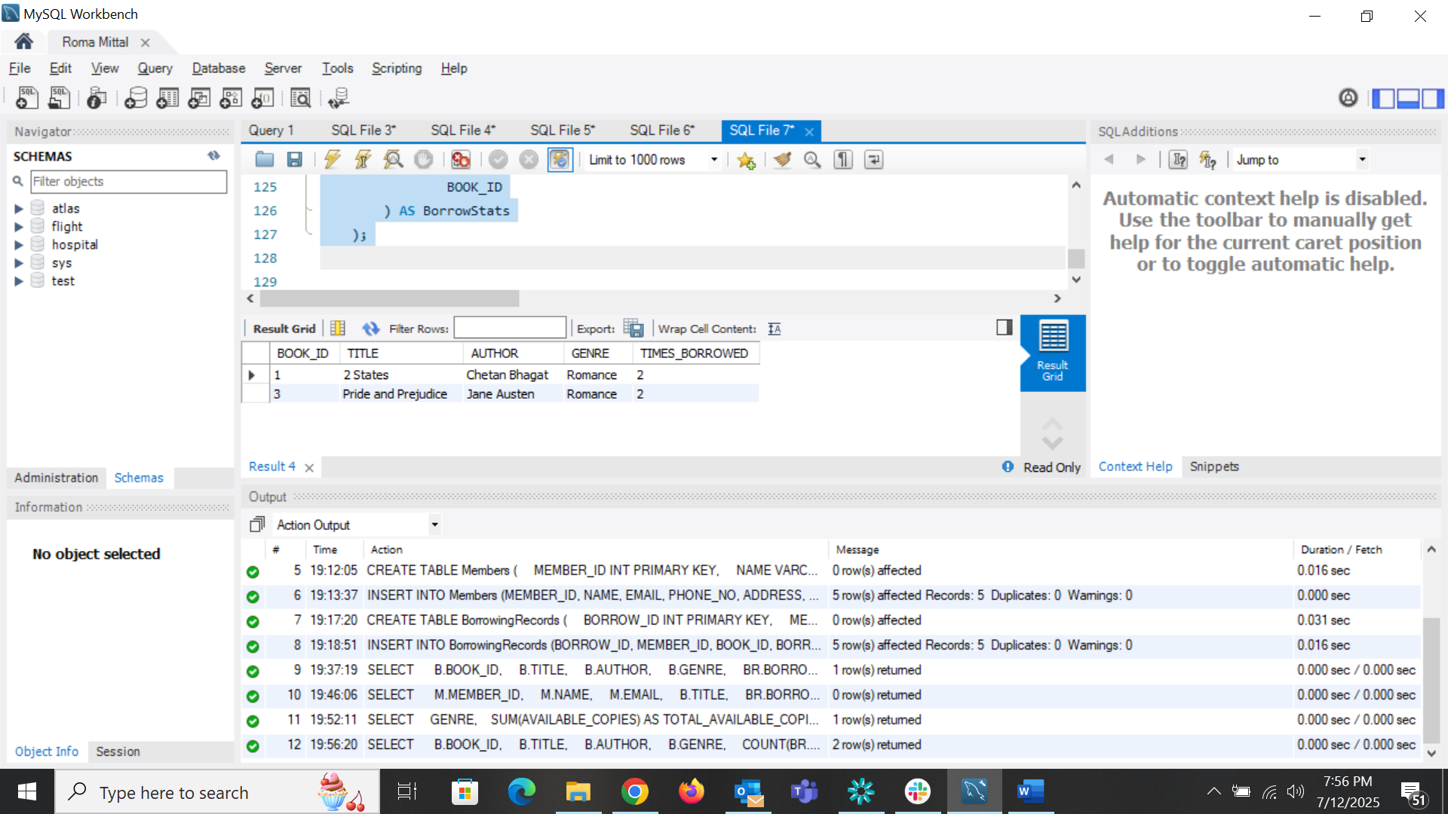

* Retrieve members who have borrowed books from at least three different genres.

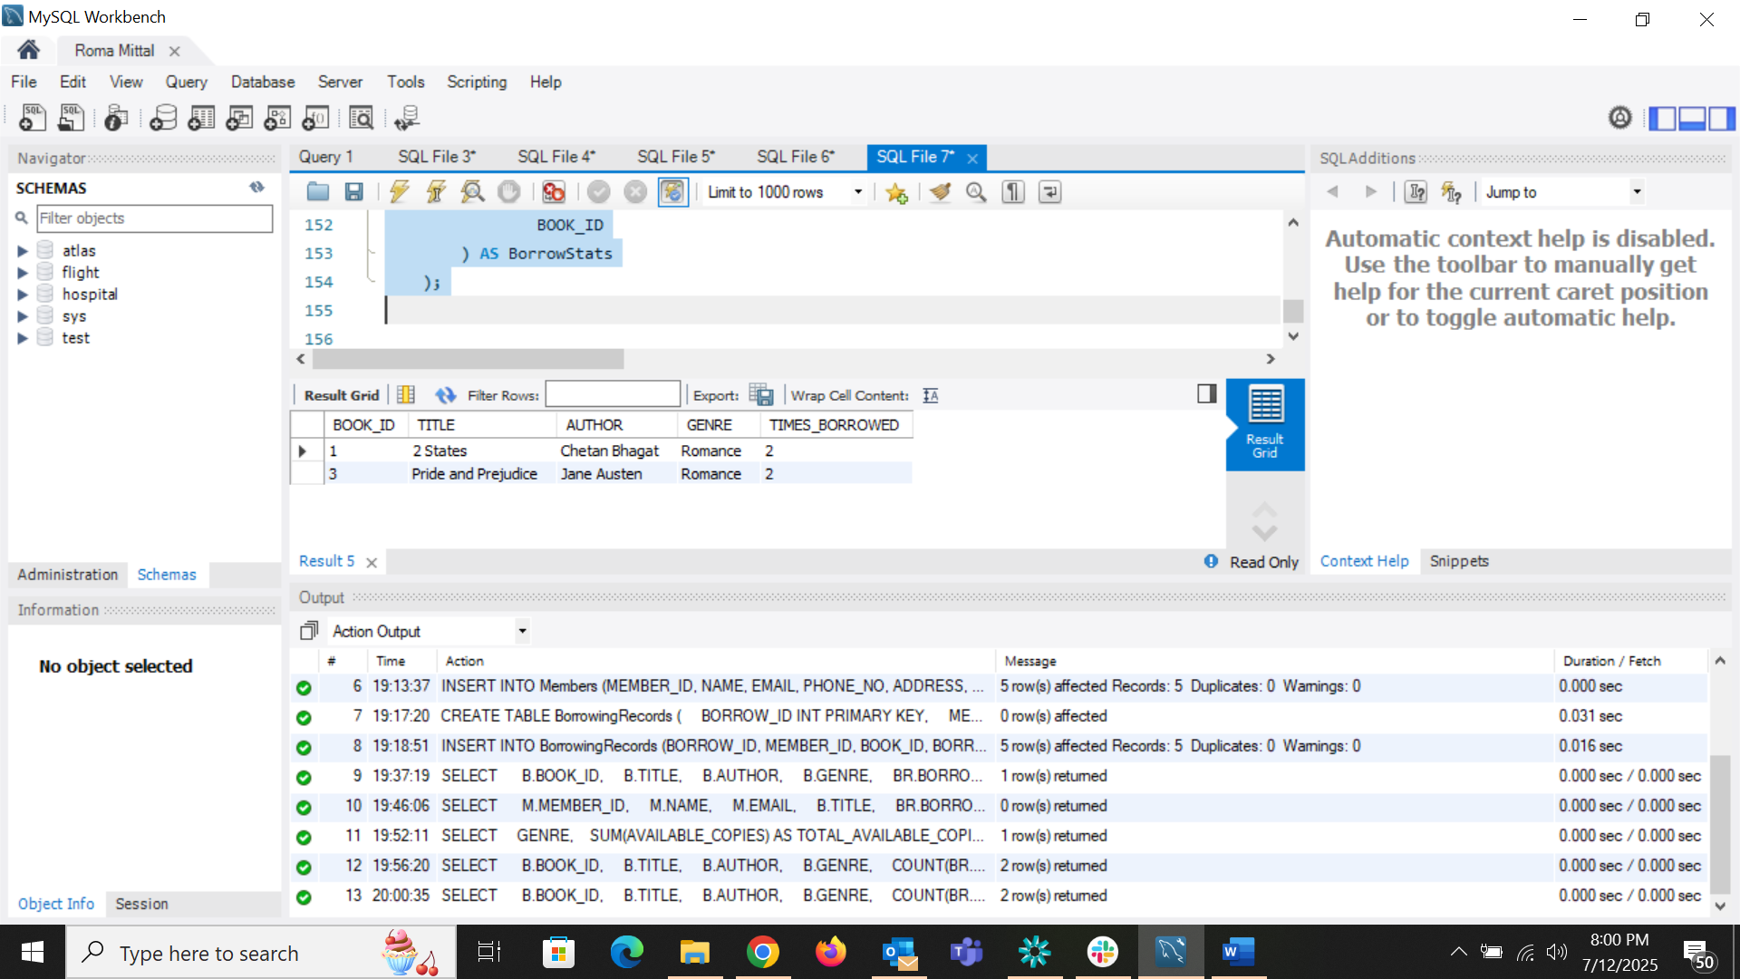

* Calculate the total number of books borrowed per month.

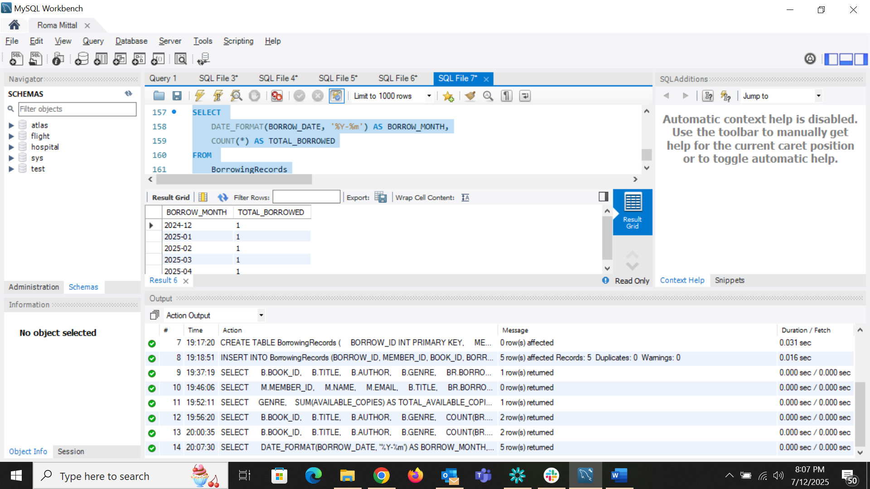

* Retrieve authors whose books have been borrowed at least 10 times.

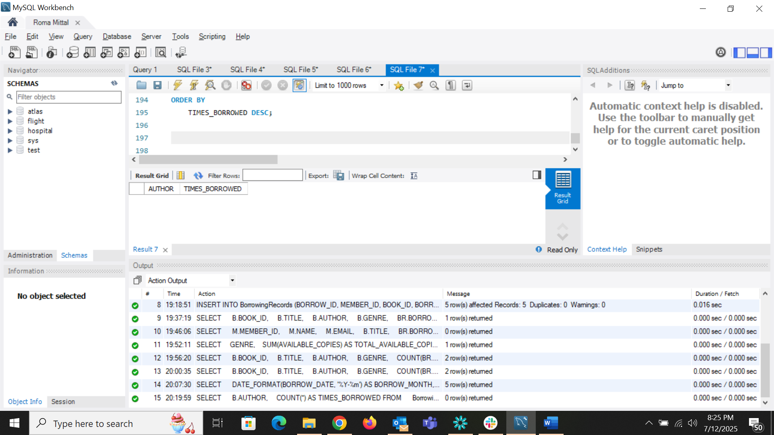

* Identify members who have never borrowed a book.

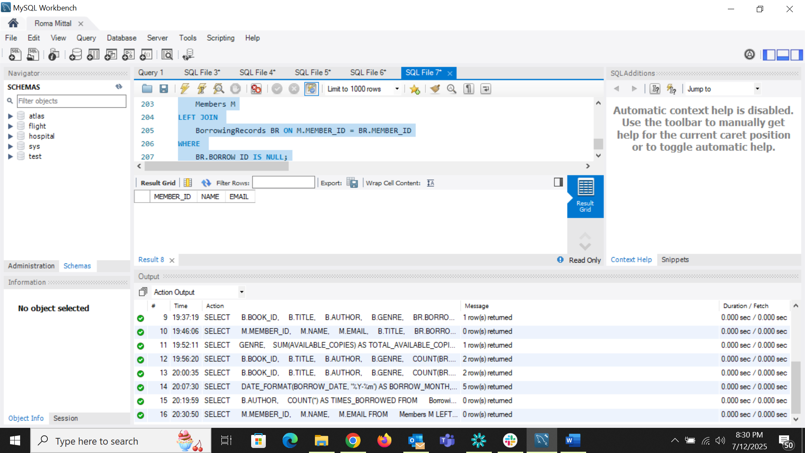

***Task 2 (Employee Payroll Management System)***

* Retrieve the list of employees sorted by salary in descending order.

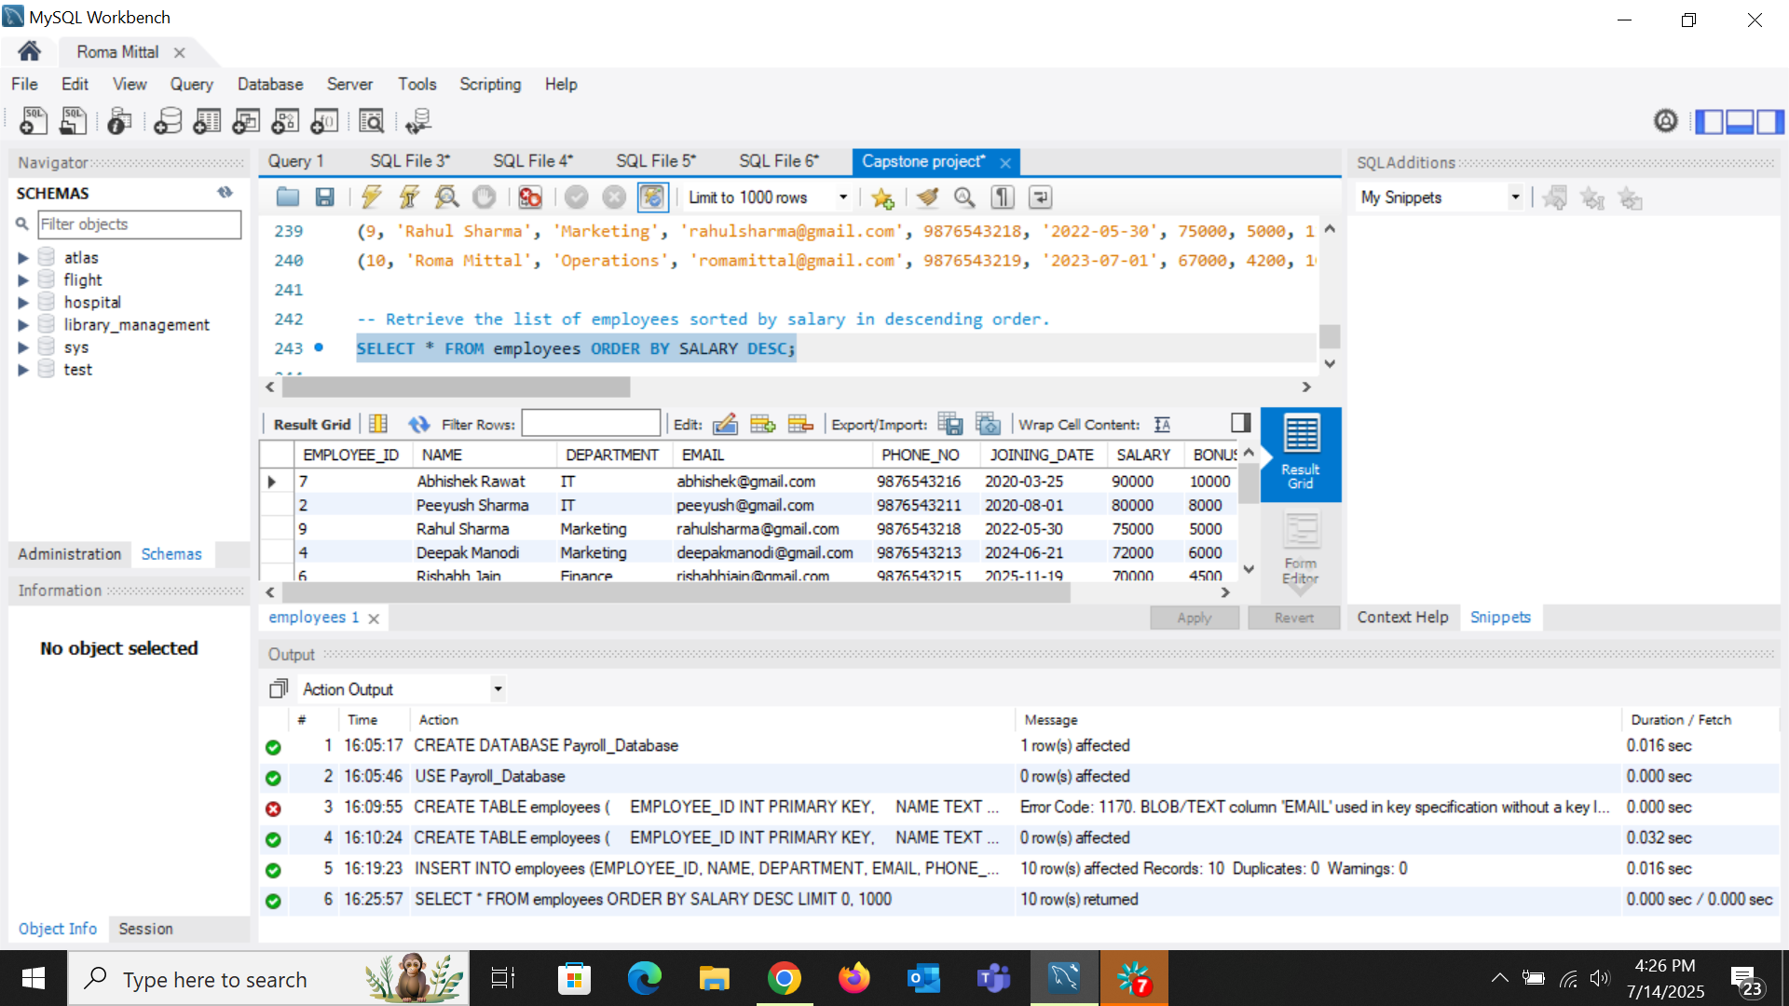

* Find employees with a total compensation (SALARY + BONUS) greater than $100,000.

Total compensation is not more than 100000 of any employee hence returning null.

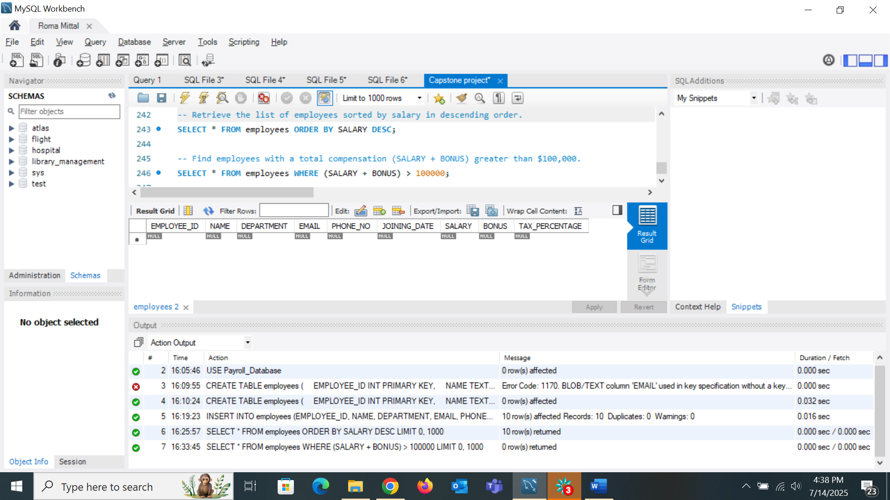

* Update the bonus for employees in the ‘Sales’ department by 10%.

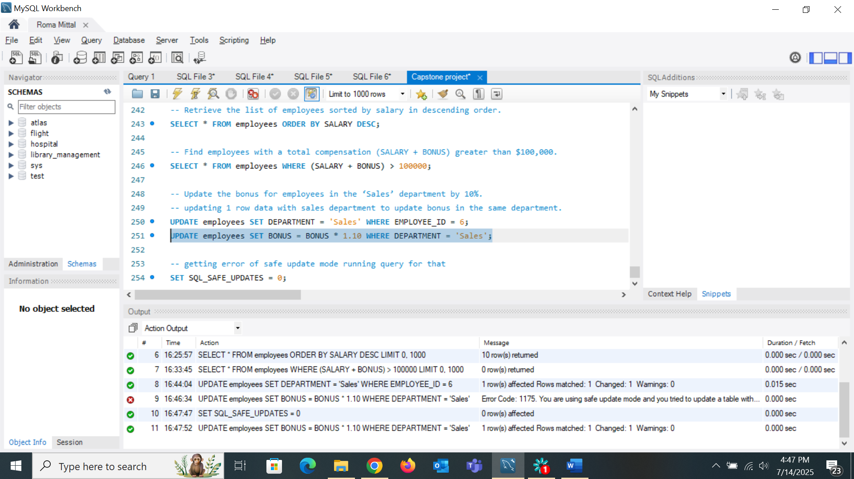

* Calculate the net salary after deducting tax for all employees.

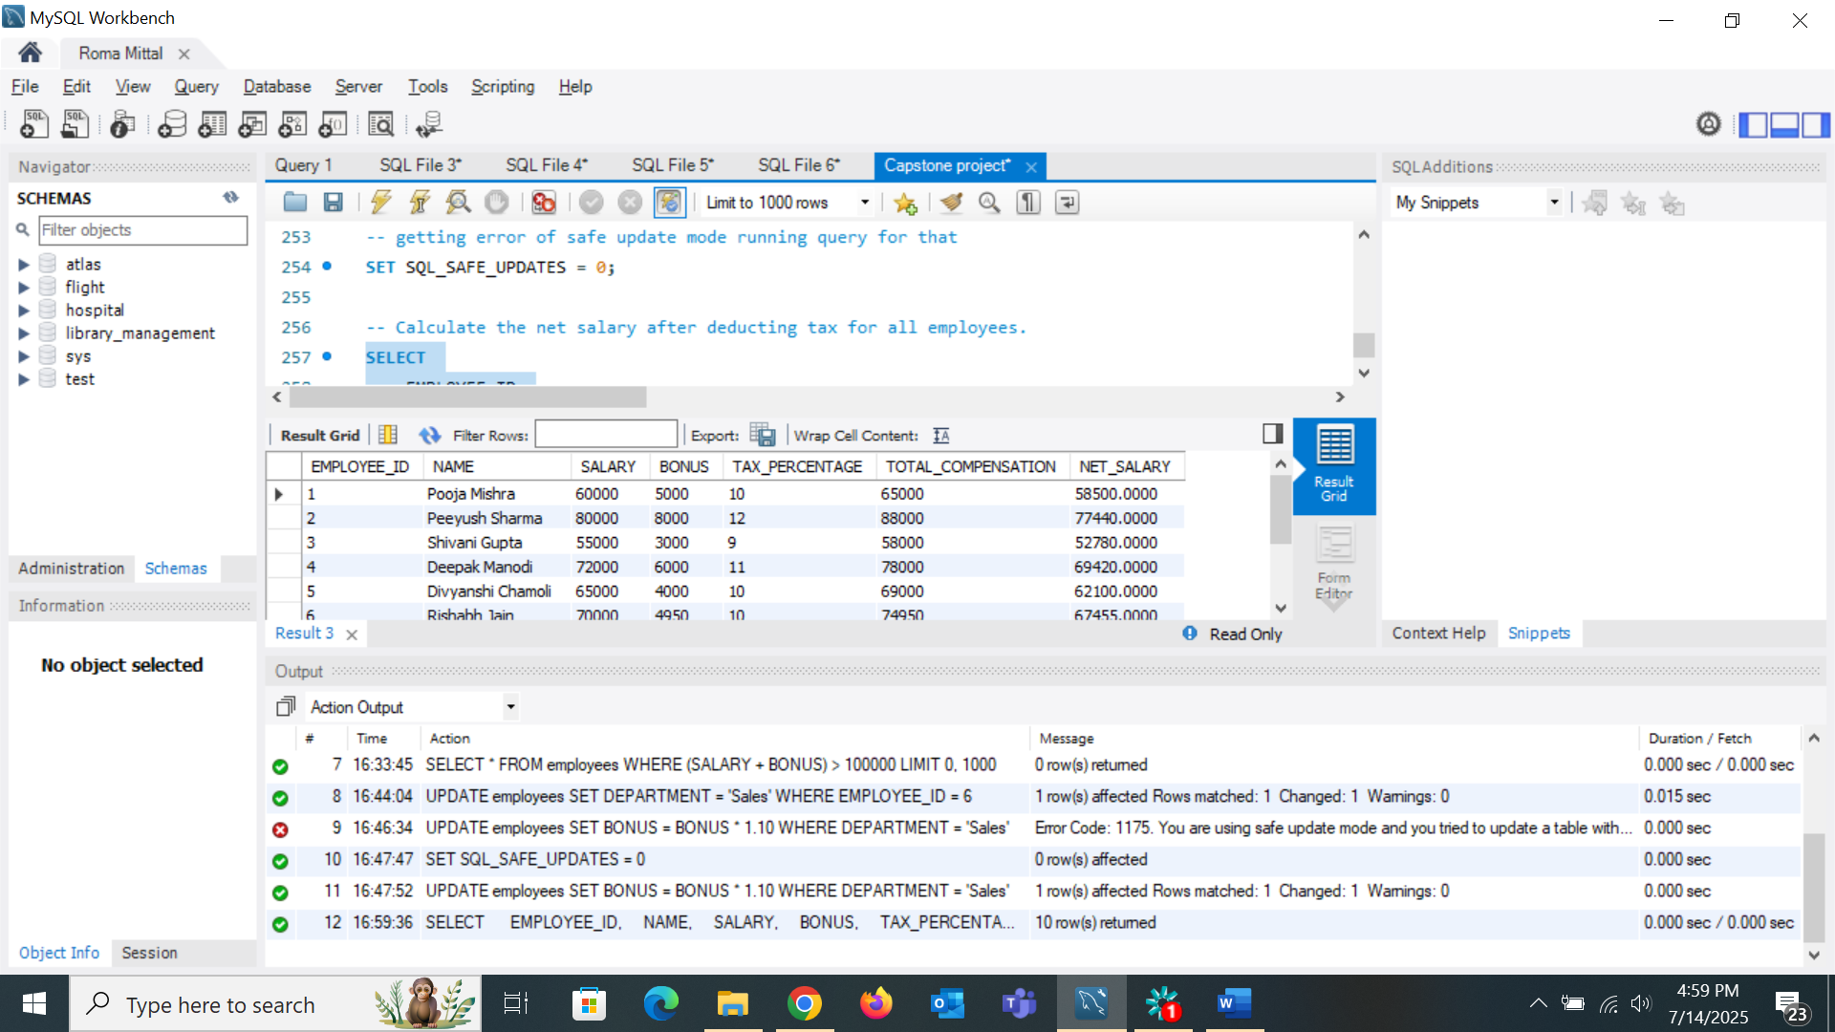

* Retrieve the average, minimum, and maximum salary per department.

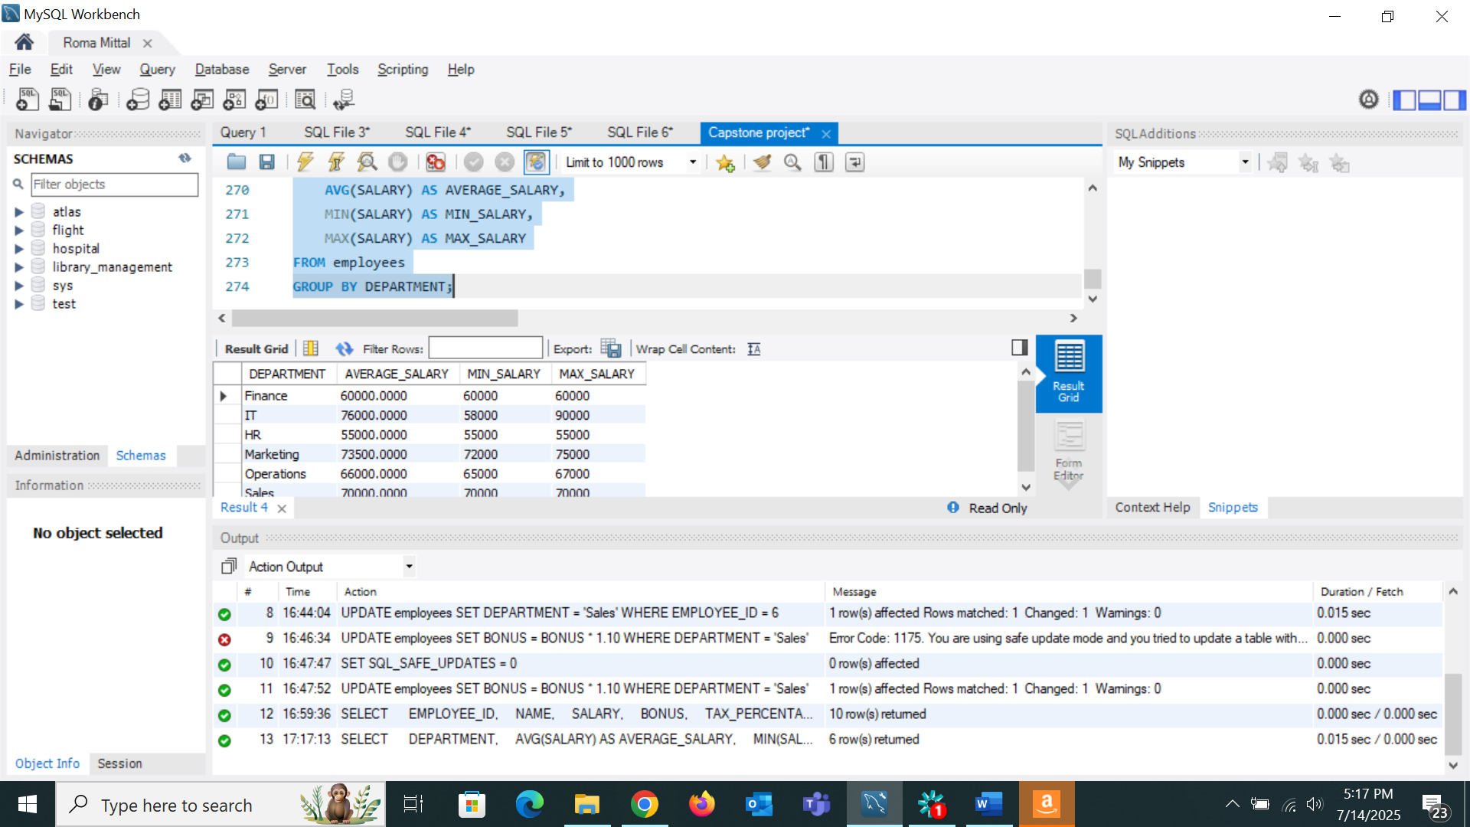

* Retrieve employees who joined in the last 6 months.

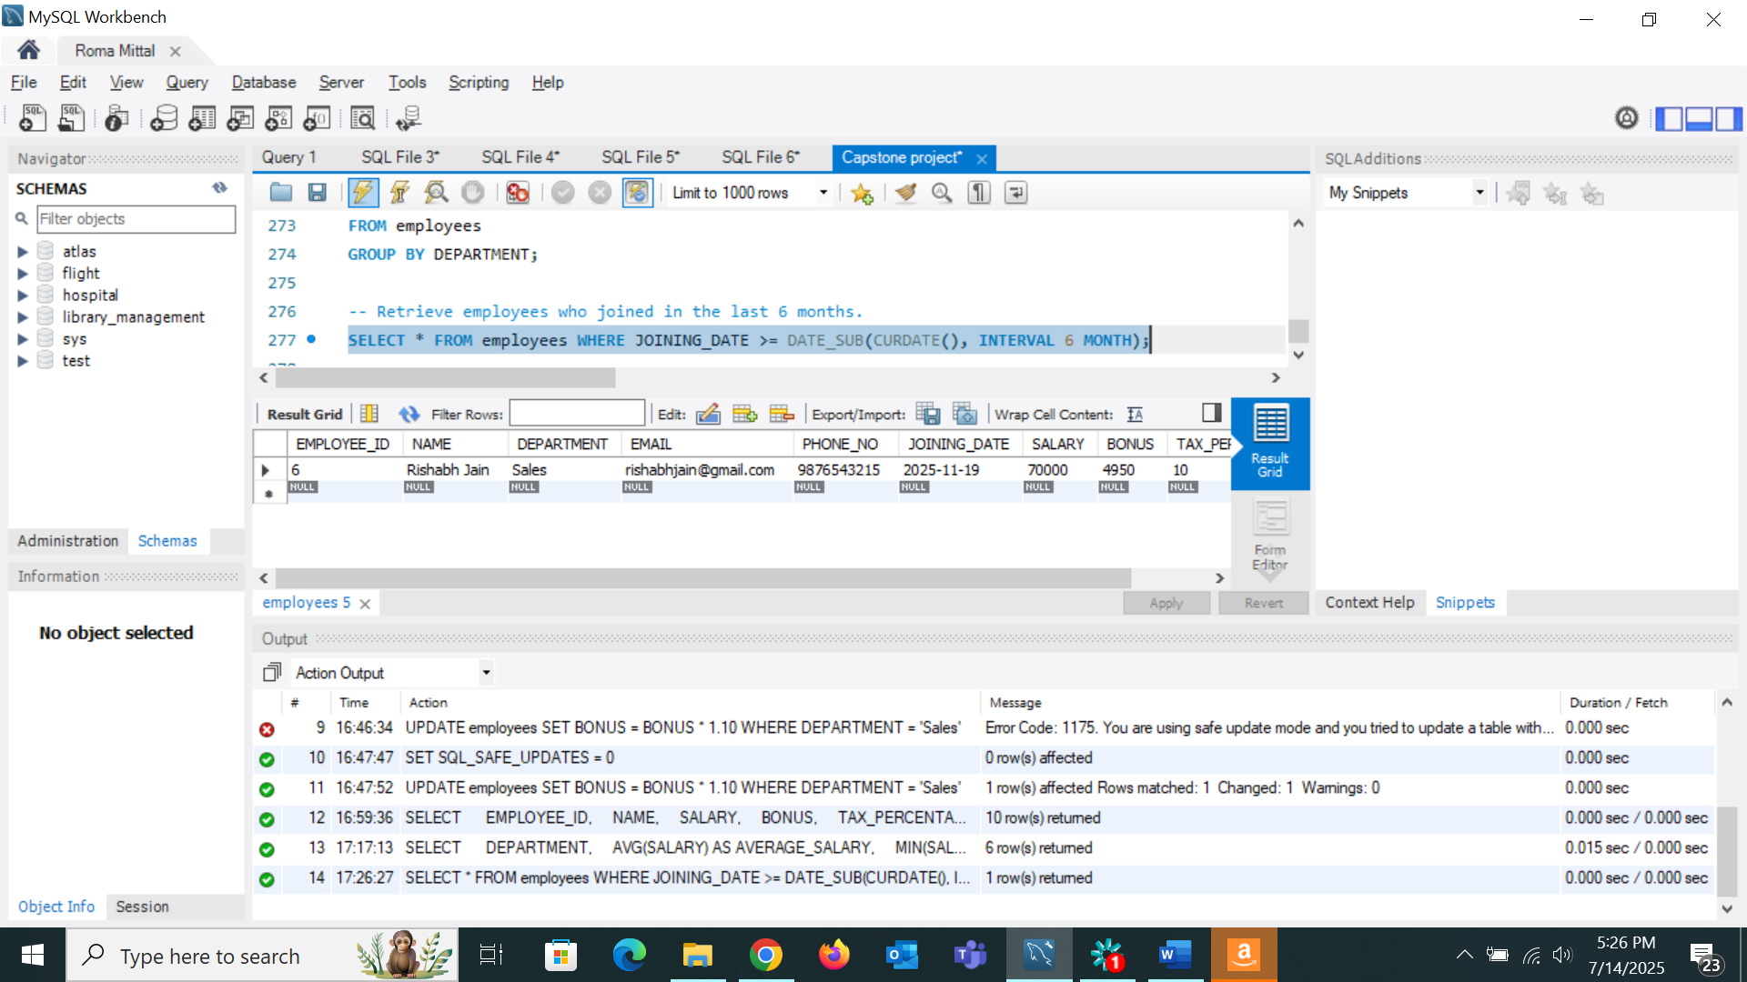

* Group employees by department and count how many employees each has.
* 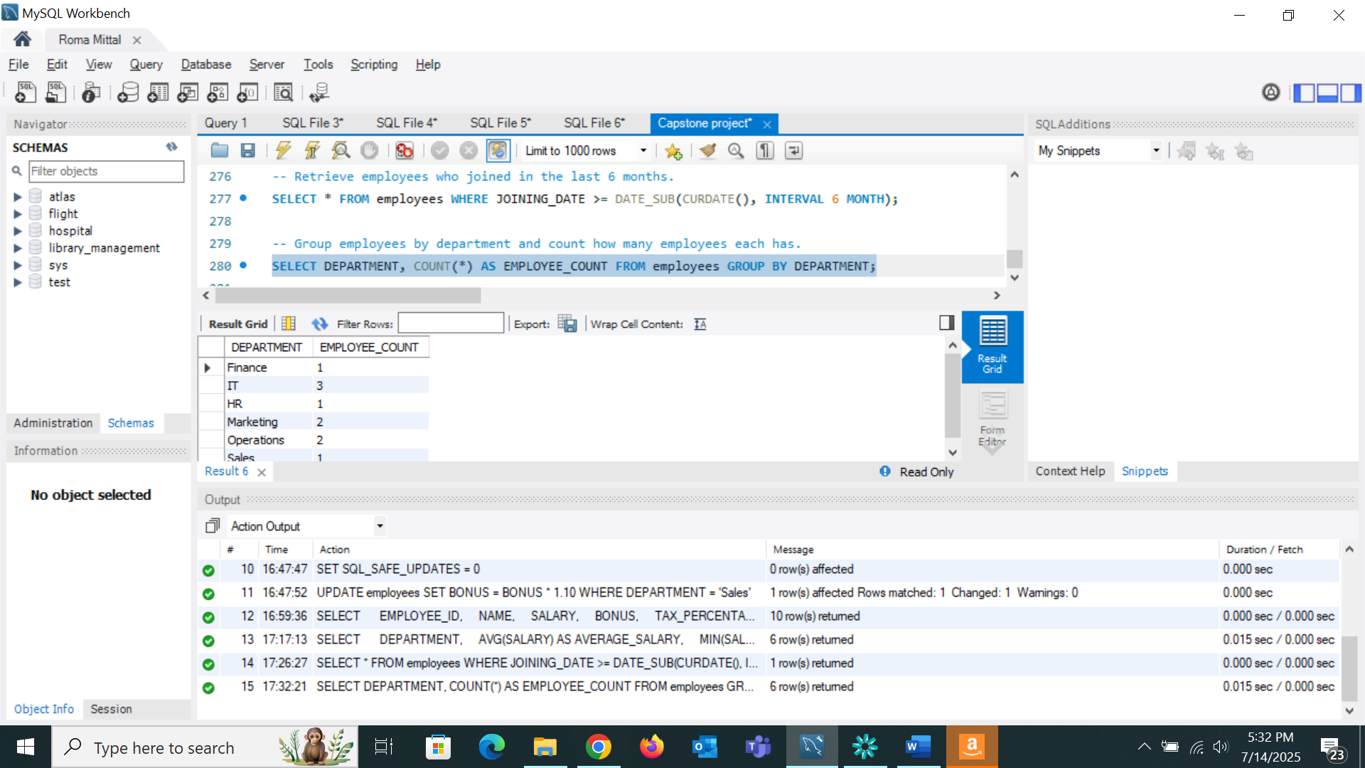
* Find the department with the highest average salary.

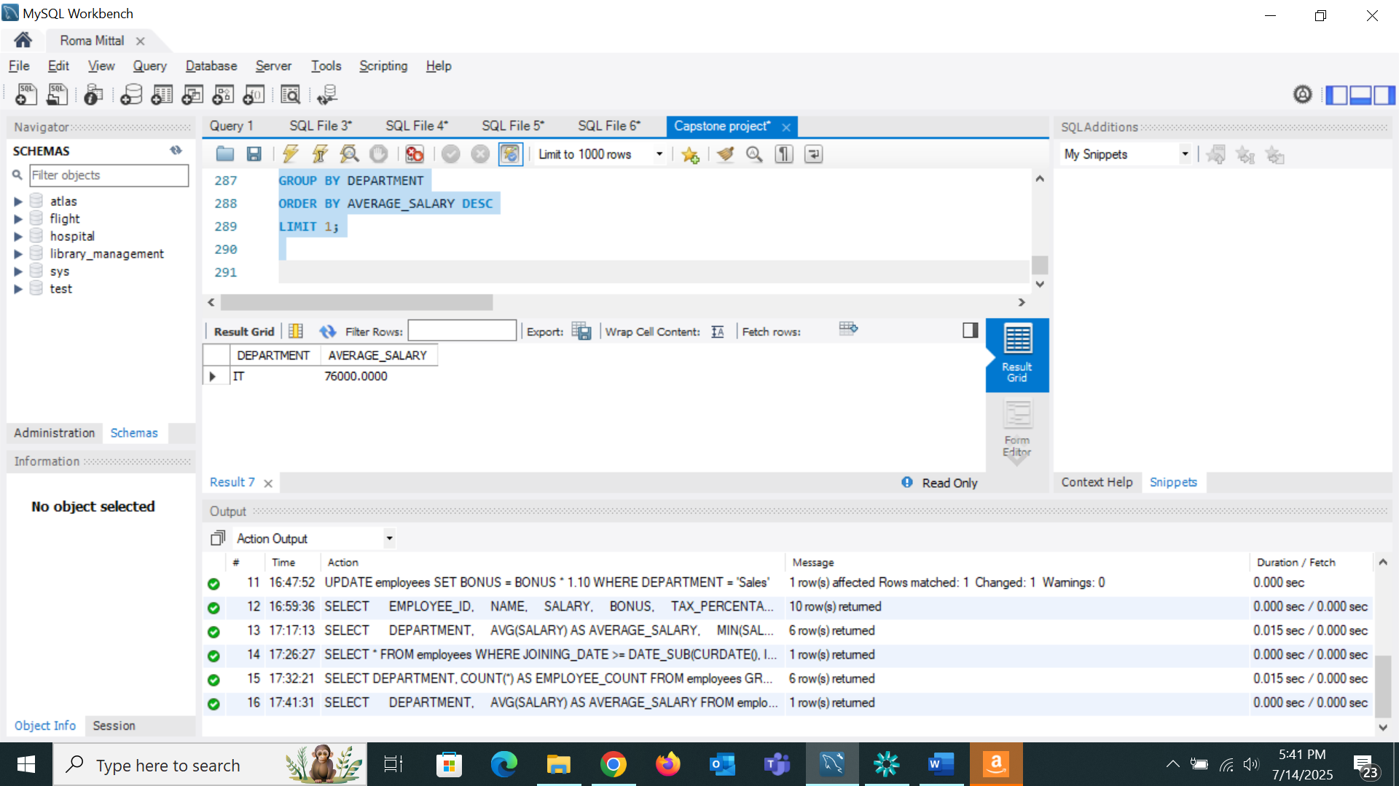

* Identify employees who have the same salary as at least one other employee.

No one has same salary hence the result is null

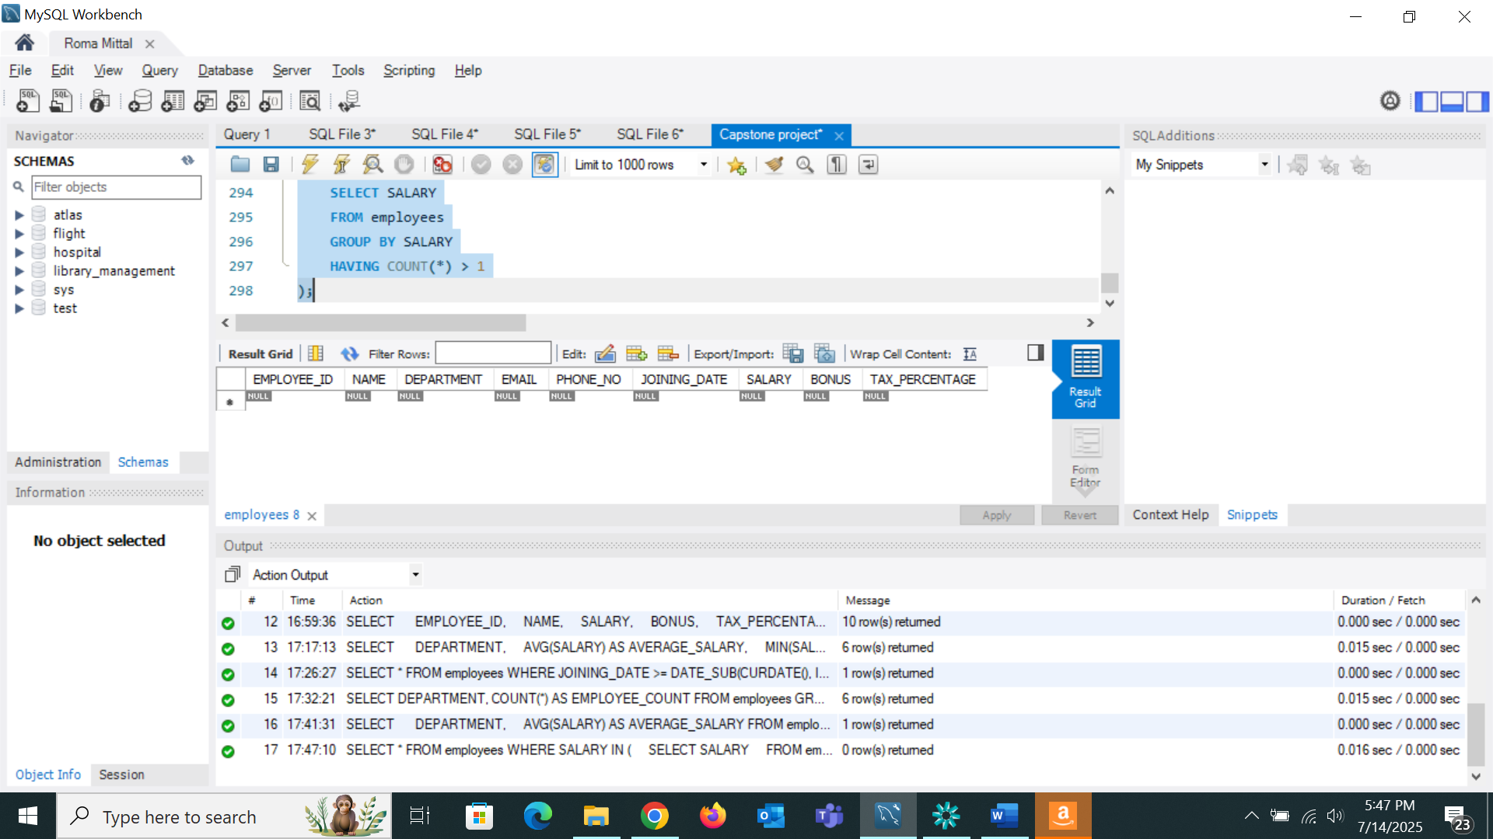

***Task 3 (Online Store Order Management System)***

* Creation of database tables

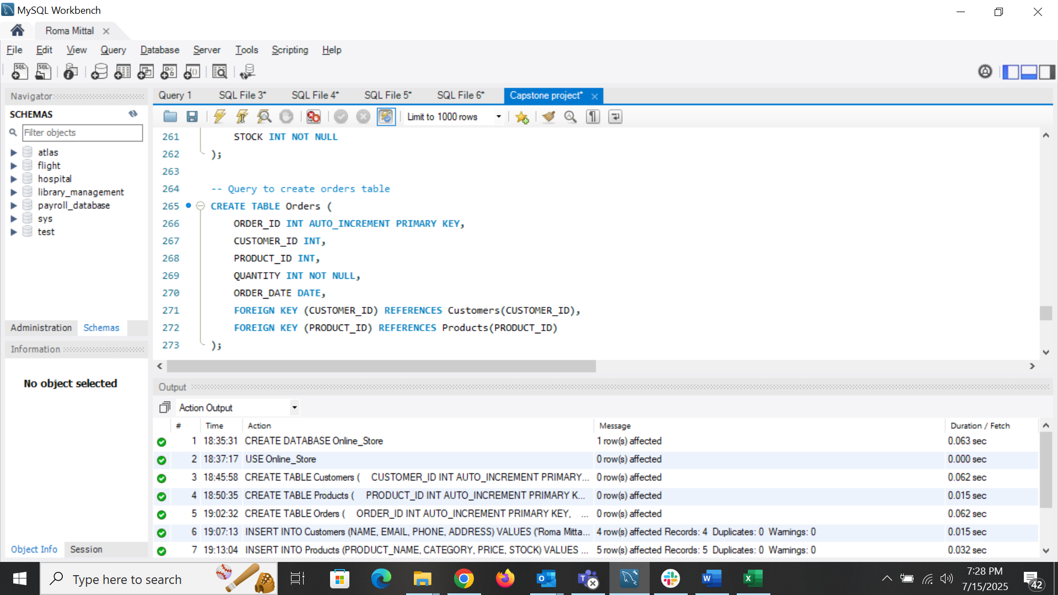

* Insertion of data

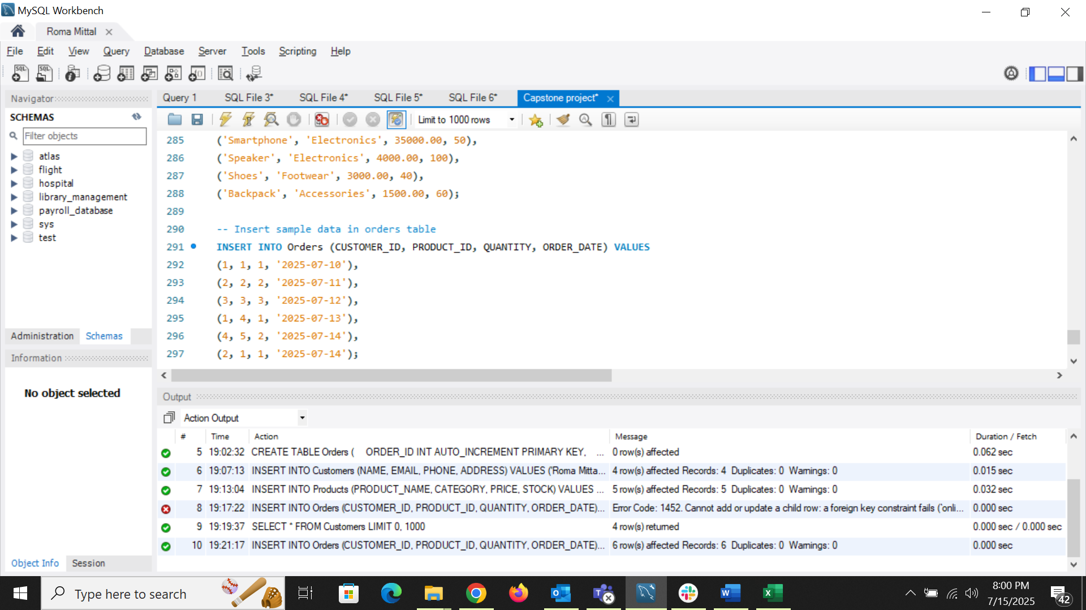

* Retrieve all orders placed by a specific customer.

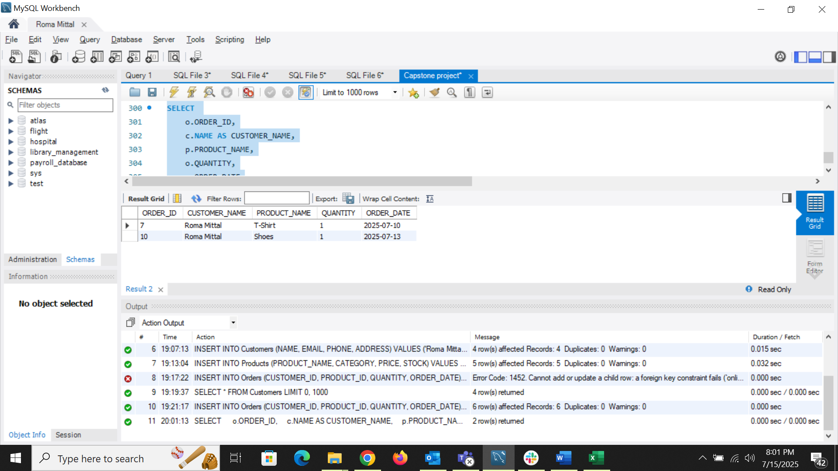

* Find products that are out of stock.

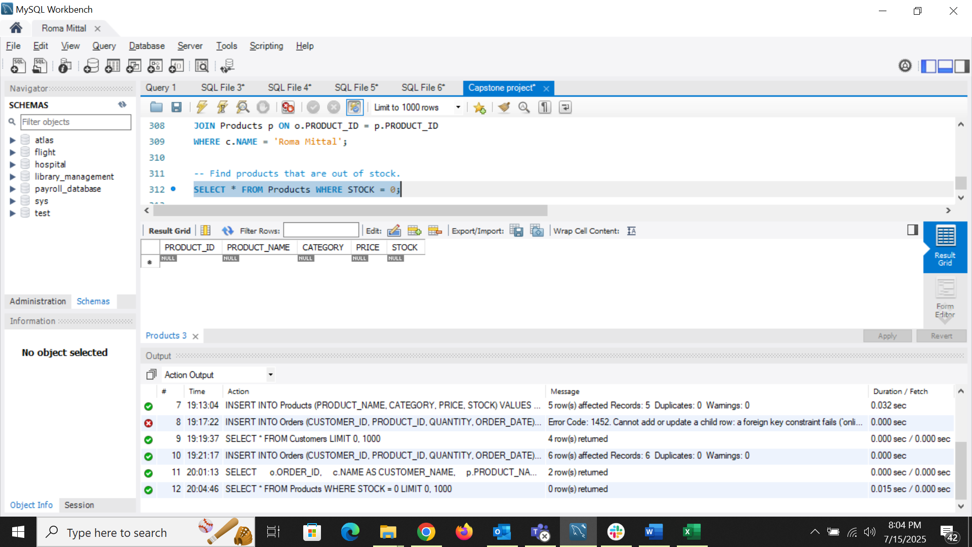

* Calculate the total revenue generated per product.

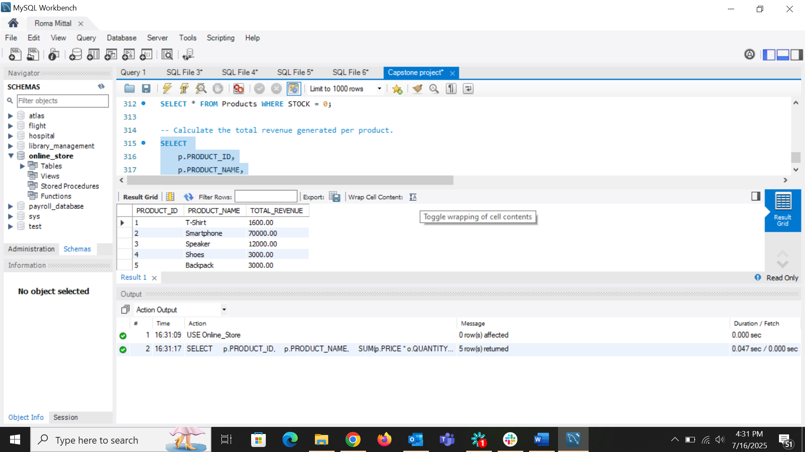

* Retrieve the top 5 customers by total purchase amount.

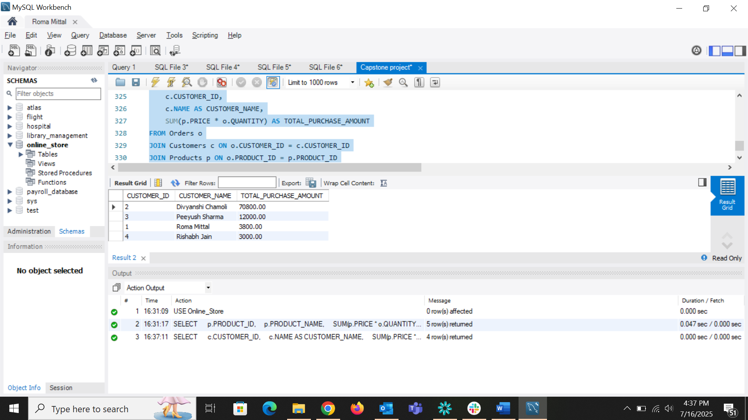

* Find customers who placed orders in at least two different product categories.

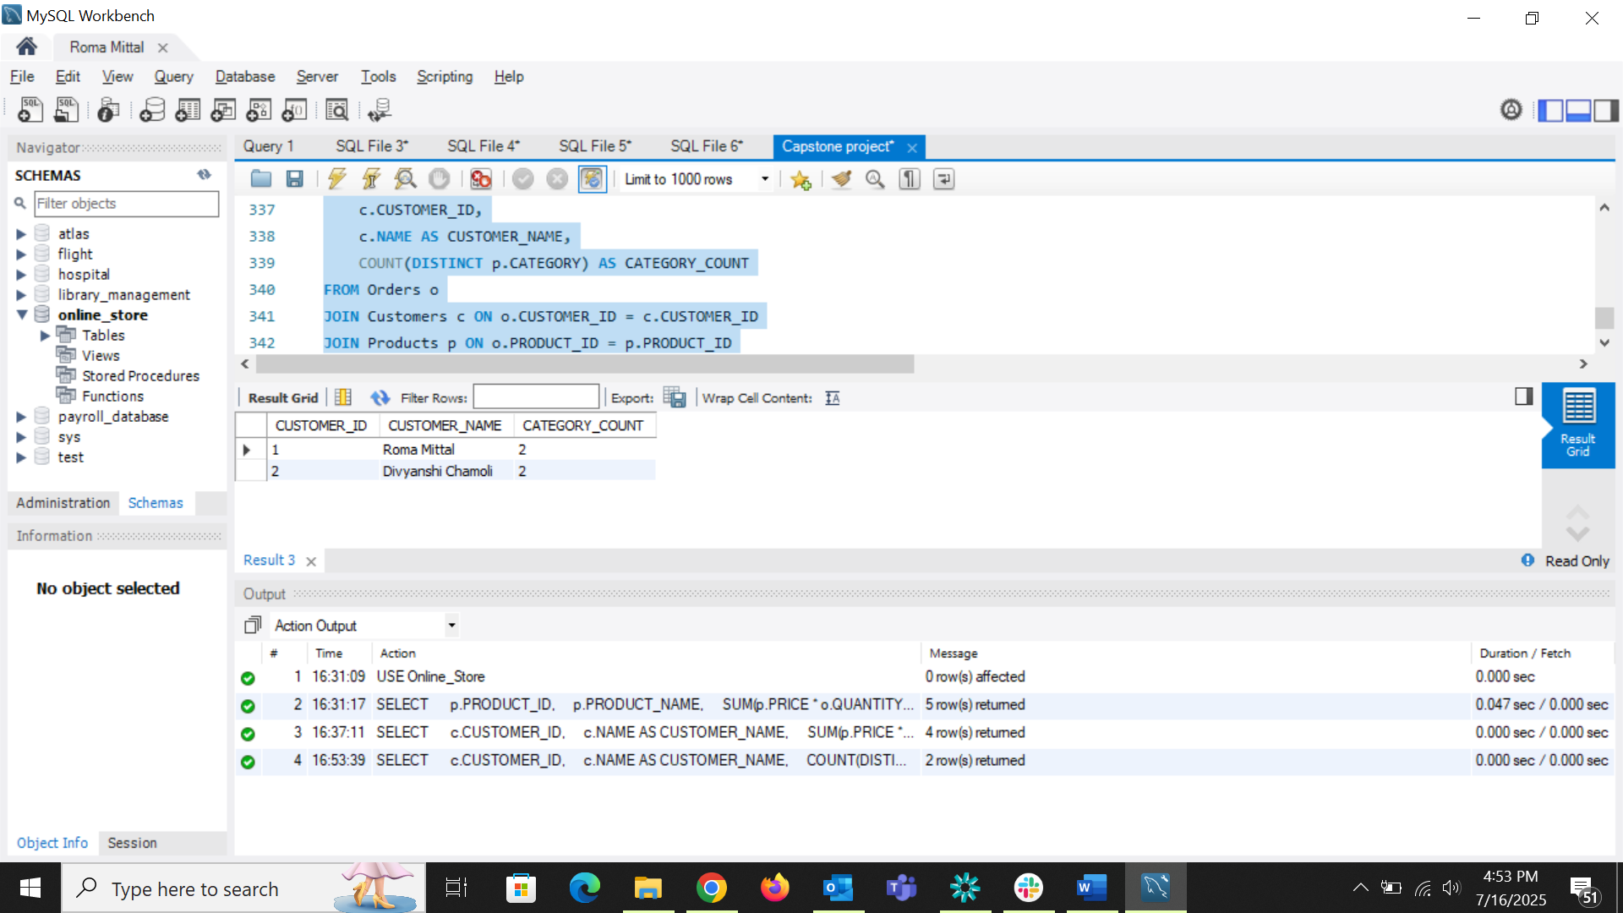

* Find the month with the highest total sales.

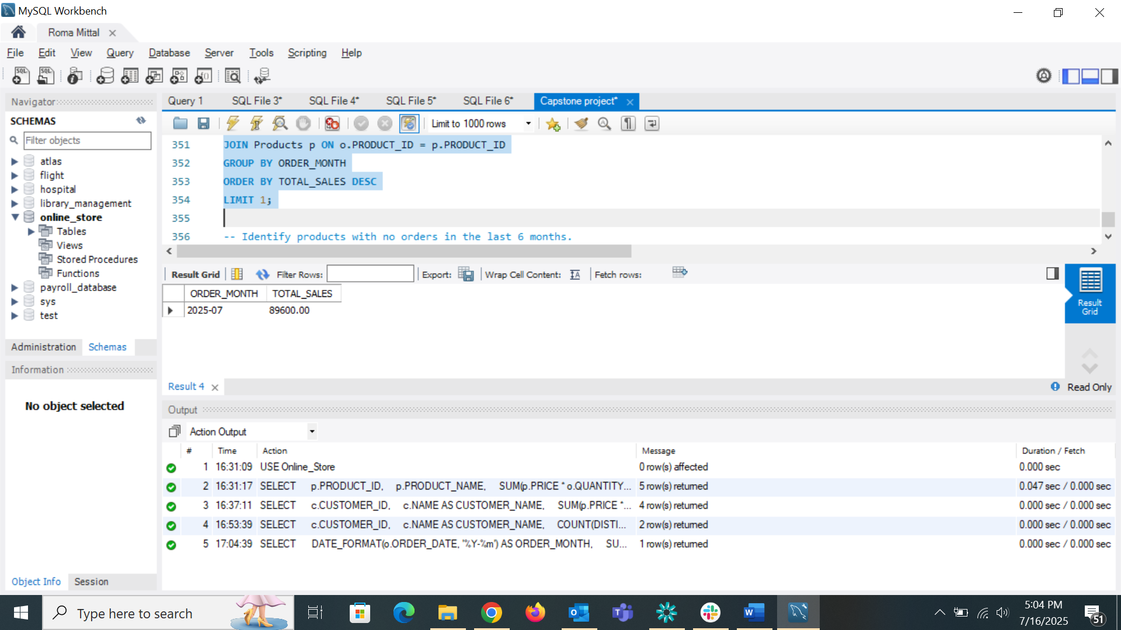

* Identify products with no orders in the last 6 months.

Sample data do not have such data hence giving null values

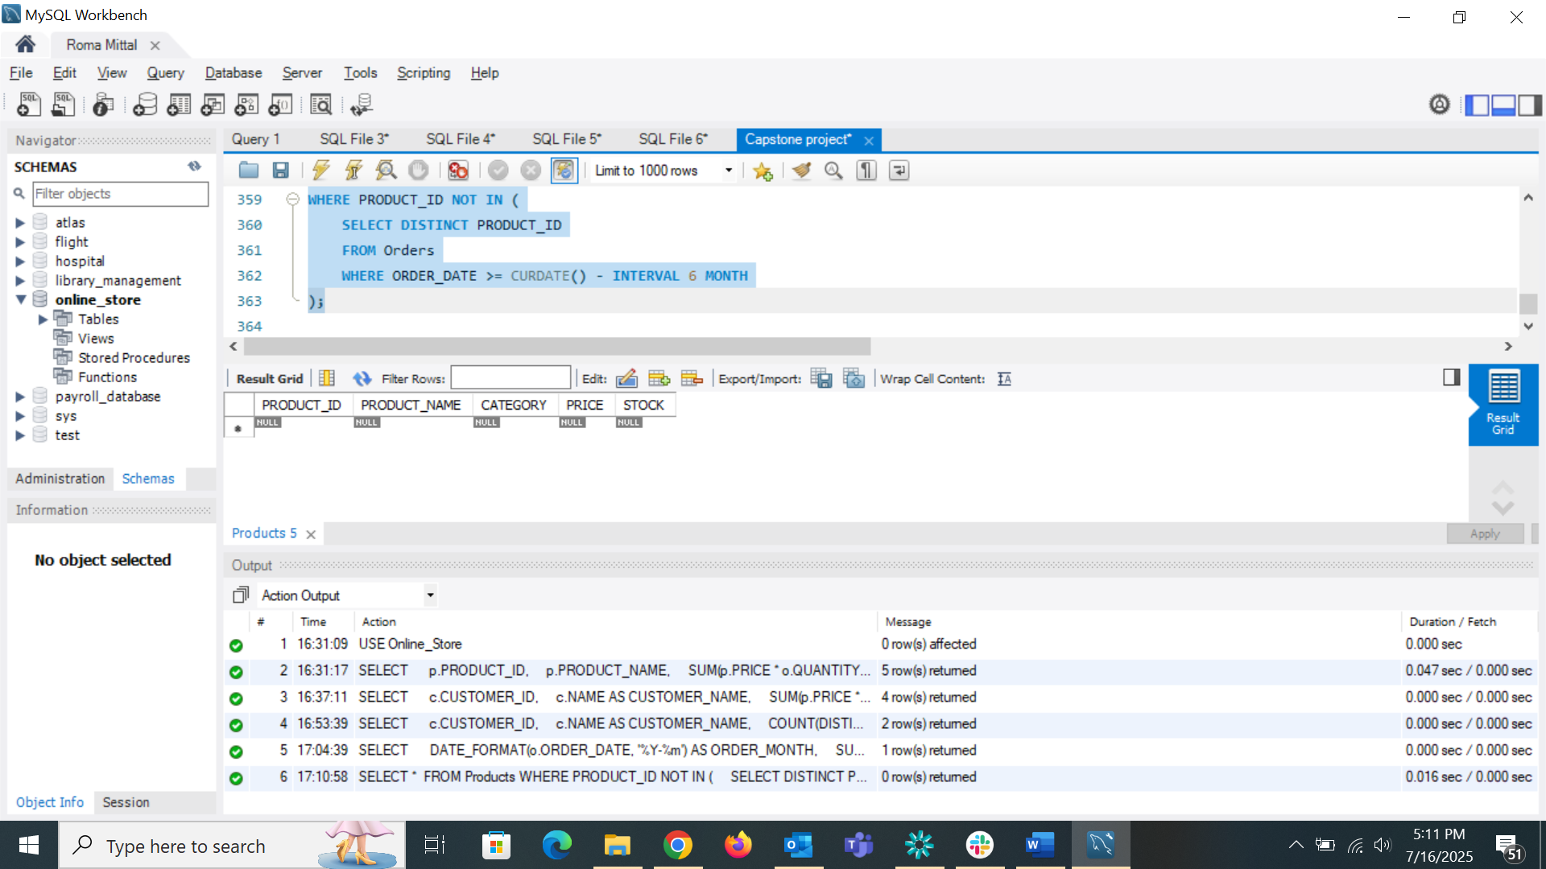

* Retrieve customers who have never placed an order.

All the customers have placed order hence returning the blank table

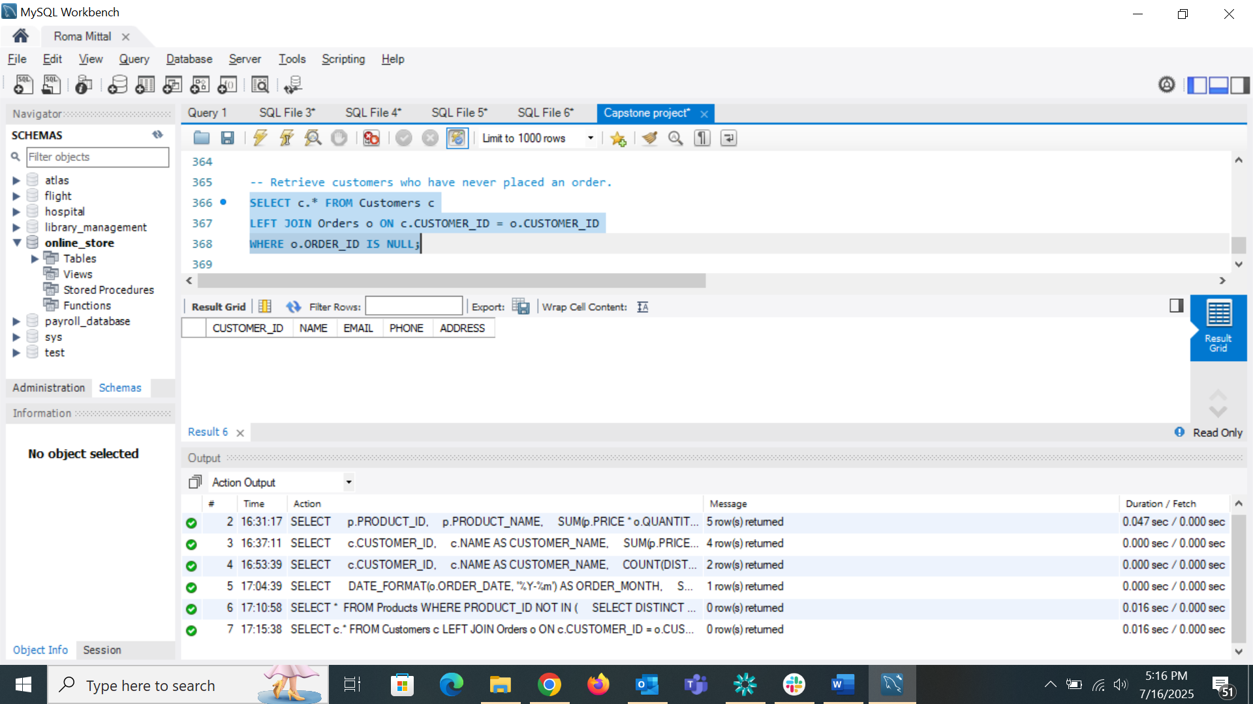

* Calculate the average order value across all orders.

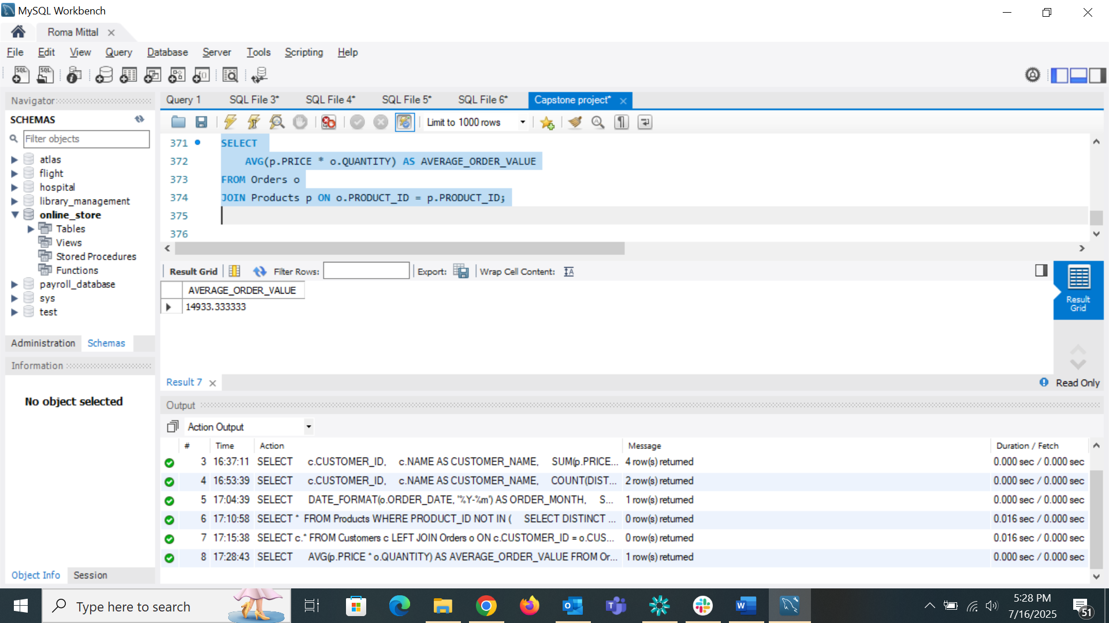

***Task 4 (Online Store Order Management System)***

* Creation of database and insertion of data
* *Drill Down: Analyze rentals from genre to individual movie level.*

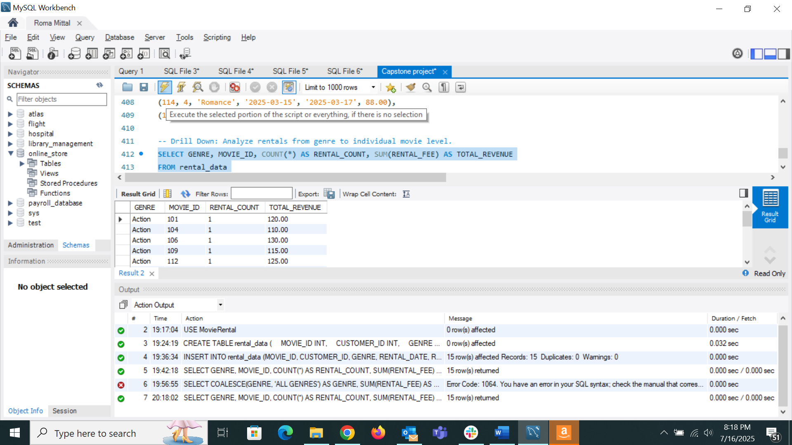

* Rollup: Summarize total rental fees by genre and then overall.

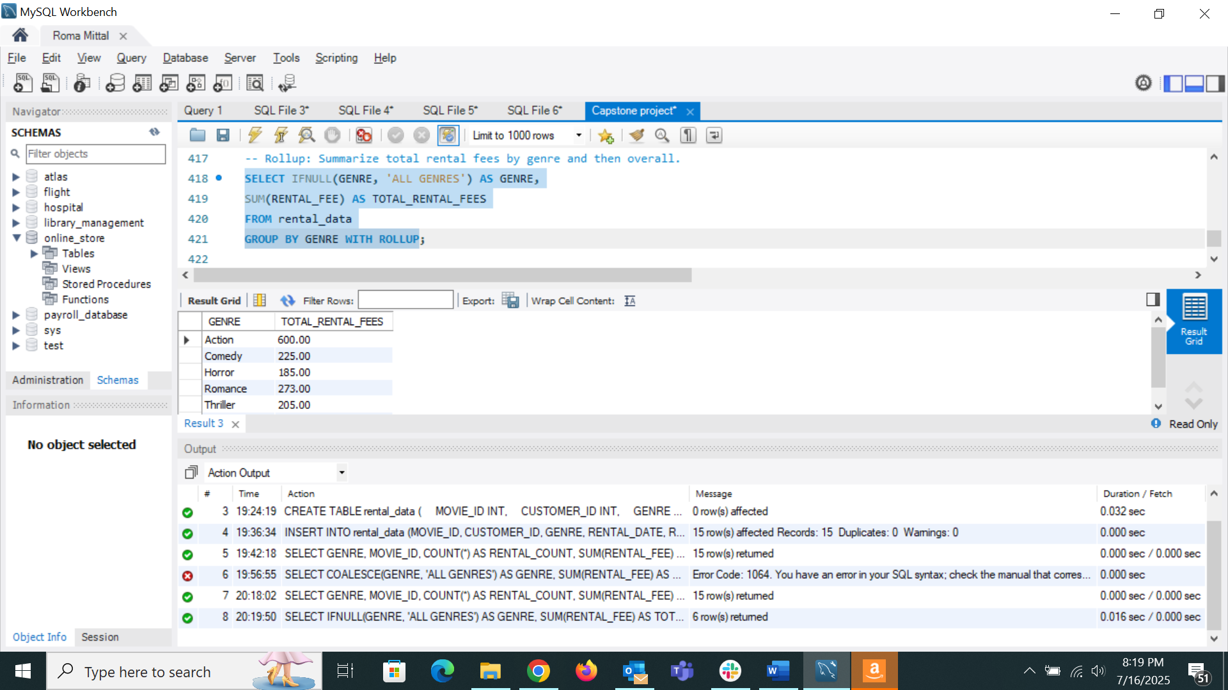

* Cube: Analyze total rental fees across combinations of genre, rental date, and customer.

Was trying to run PostgreSQL in MySQL

* Fees by GENRE

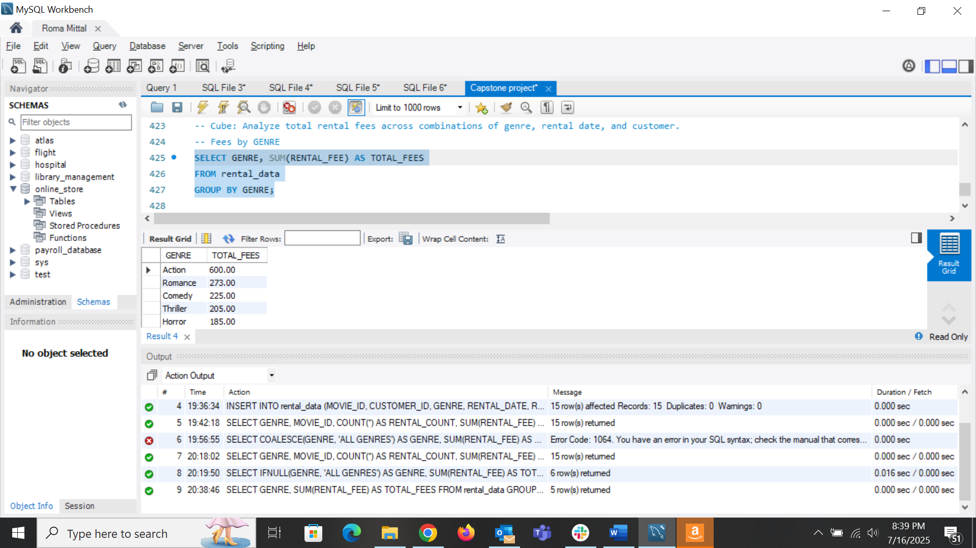

* Fees by RENTAL_DATE

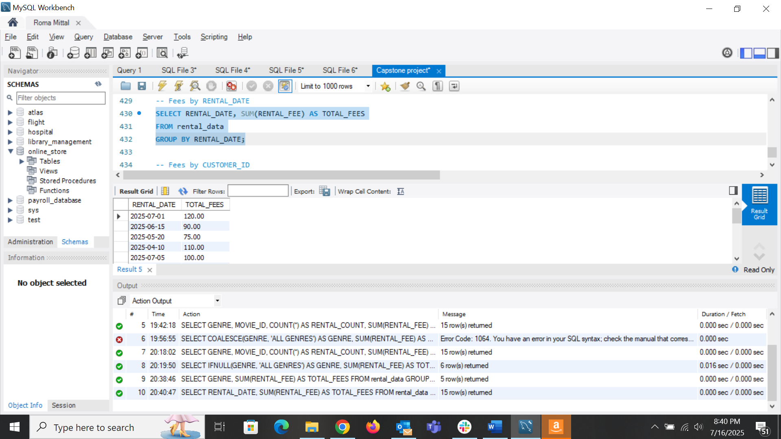

* Fees by CUSTOMER_ID

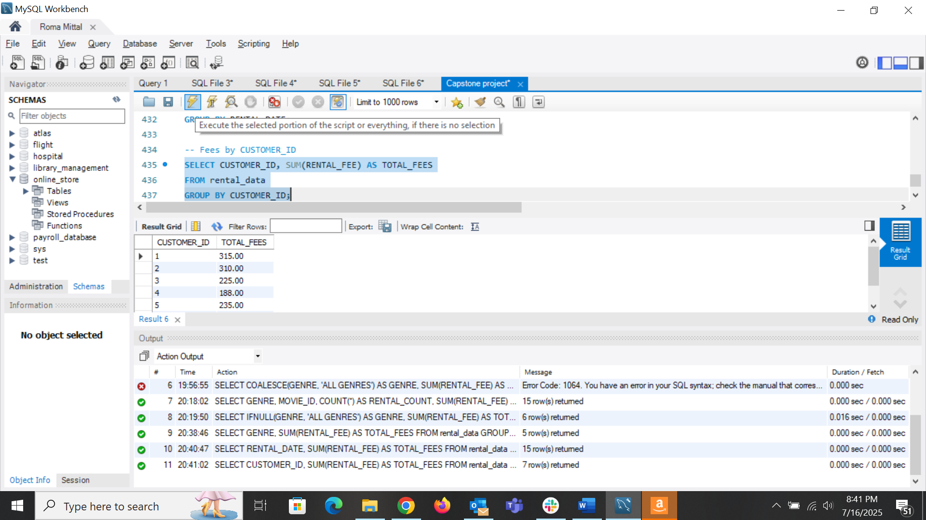

* Slice: Extract rentals only from the ‘Action’ genre.

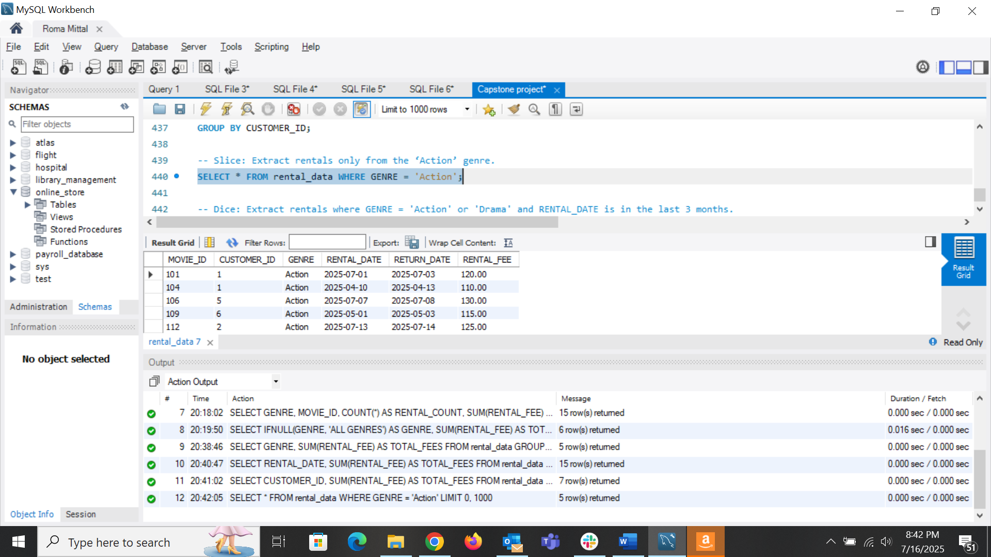

* Dice: Extract rentals where GENRE = 'Action' or 'Drama' and RENTAL_DATE is in the last 3 months.

